**Online – TestNG Setup**

**Session2:**

# 1.TestNG setup and Usage:

First screenshot explains TestNG and it's URL.

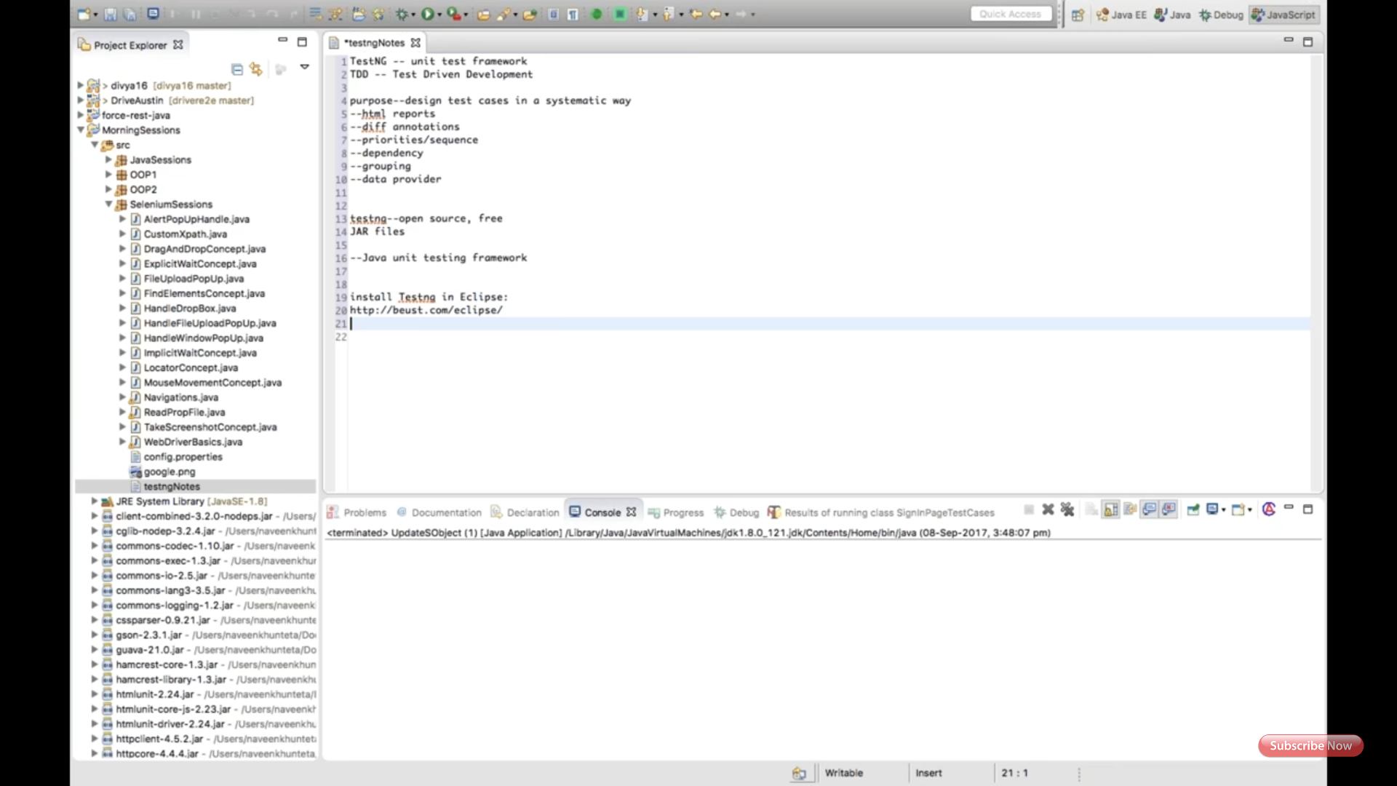

Second screenshot explains where to click in eclipse. Help-- Install New Software.

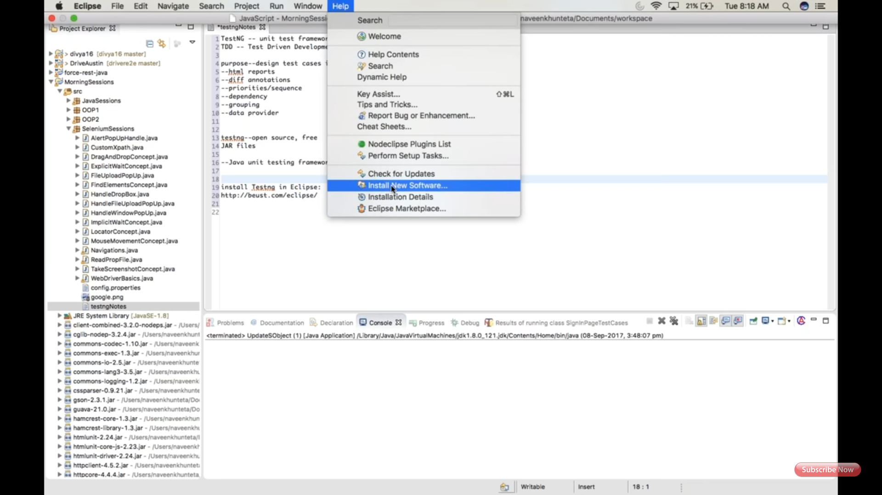

Third screenshot explains providing TestNG URL and search. **(Note: Working URL: http://beust.com/eclipse/)**

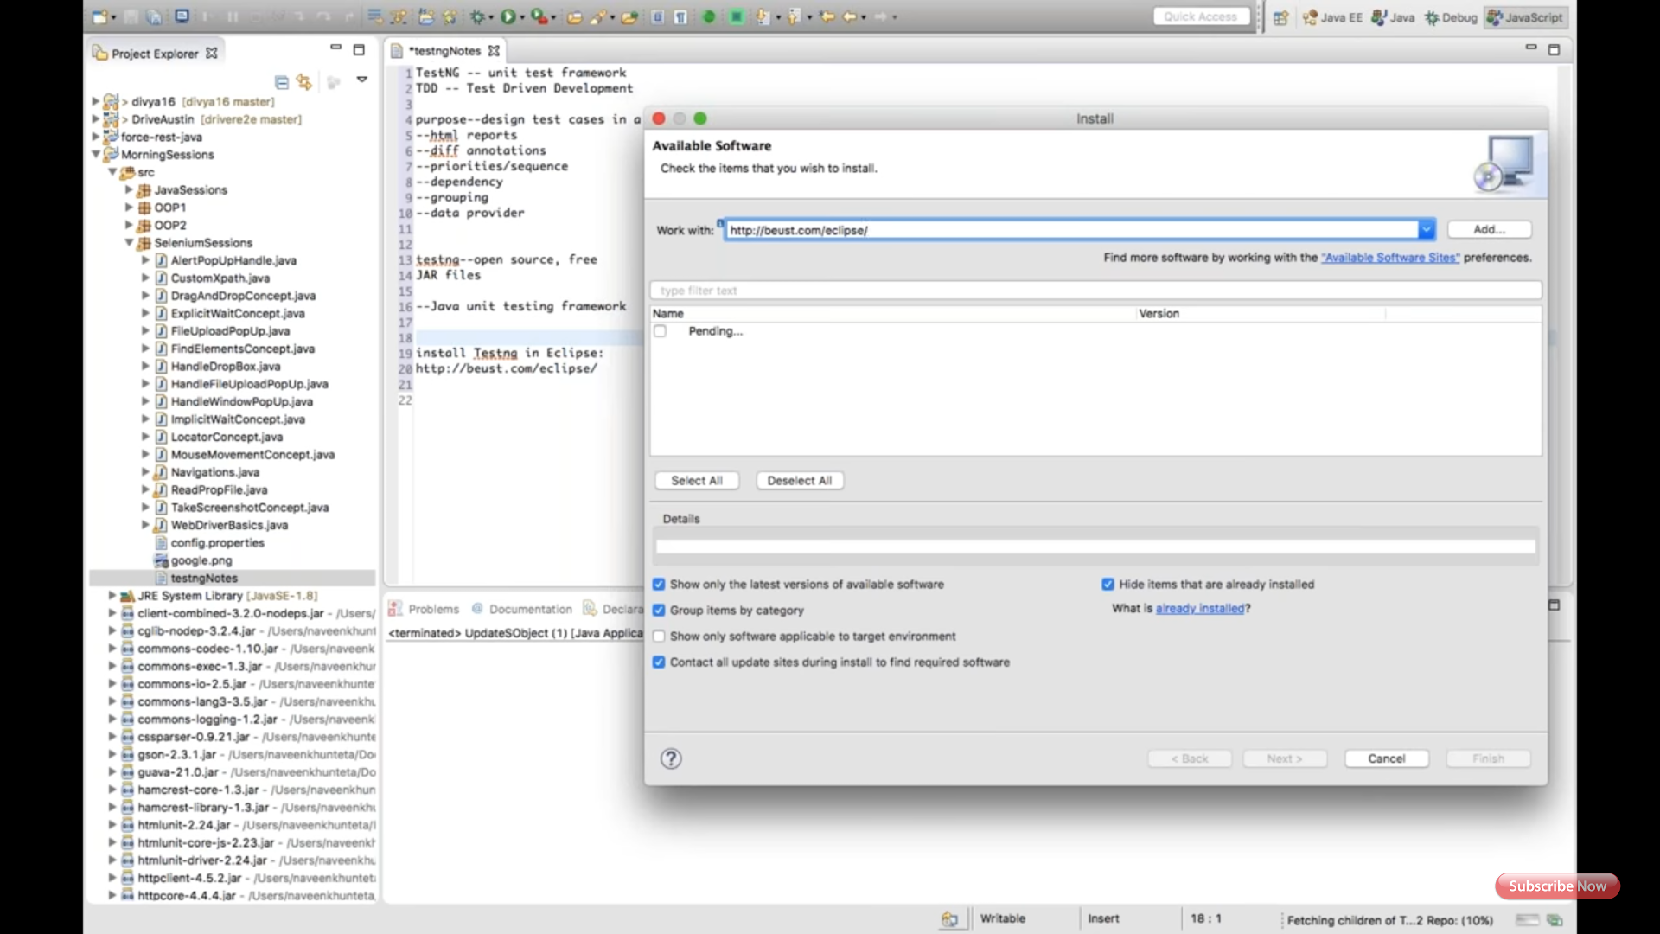

Forth screenshot explains click on TestNG and contact all check box. Next, Accept, Finish.

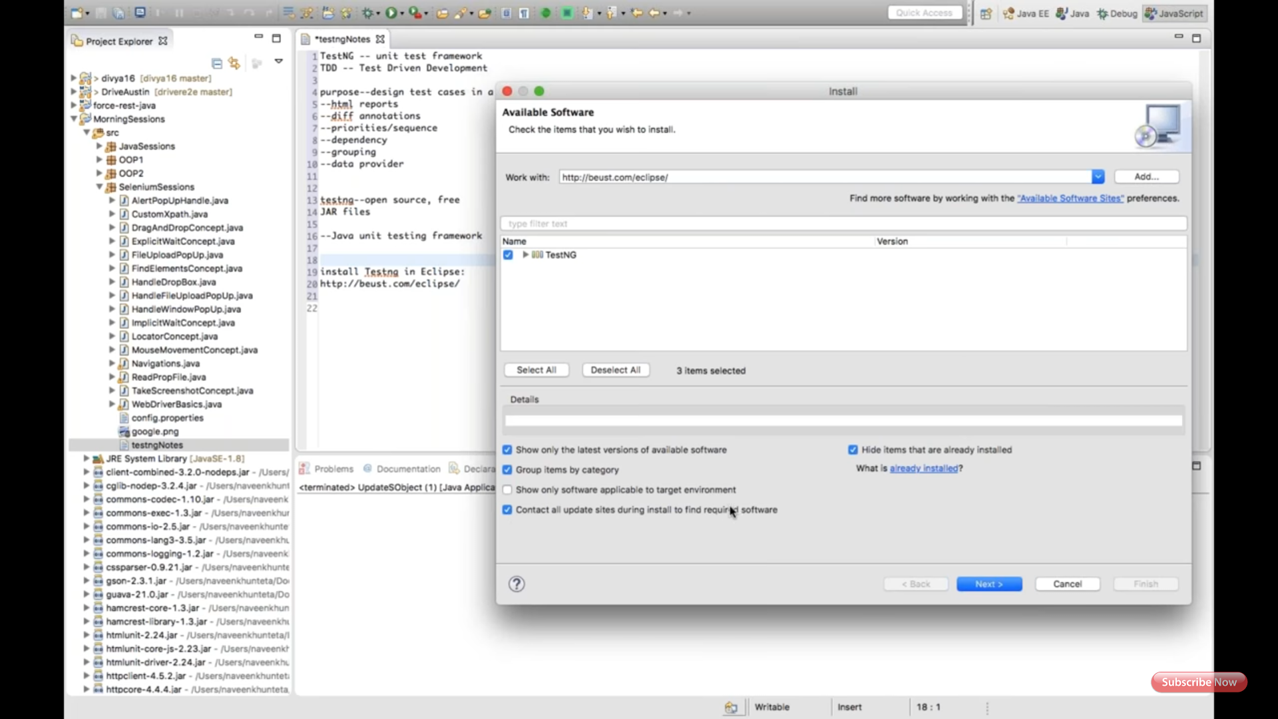

Fifth screenshot explains installation of TestNG.

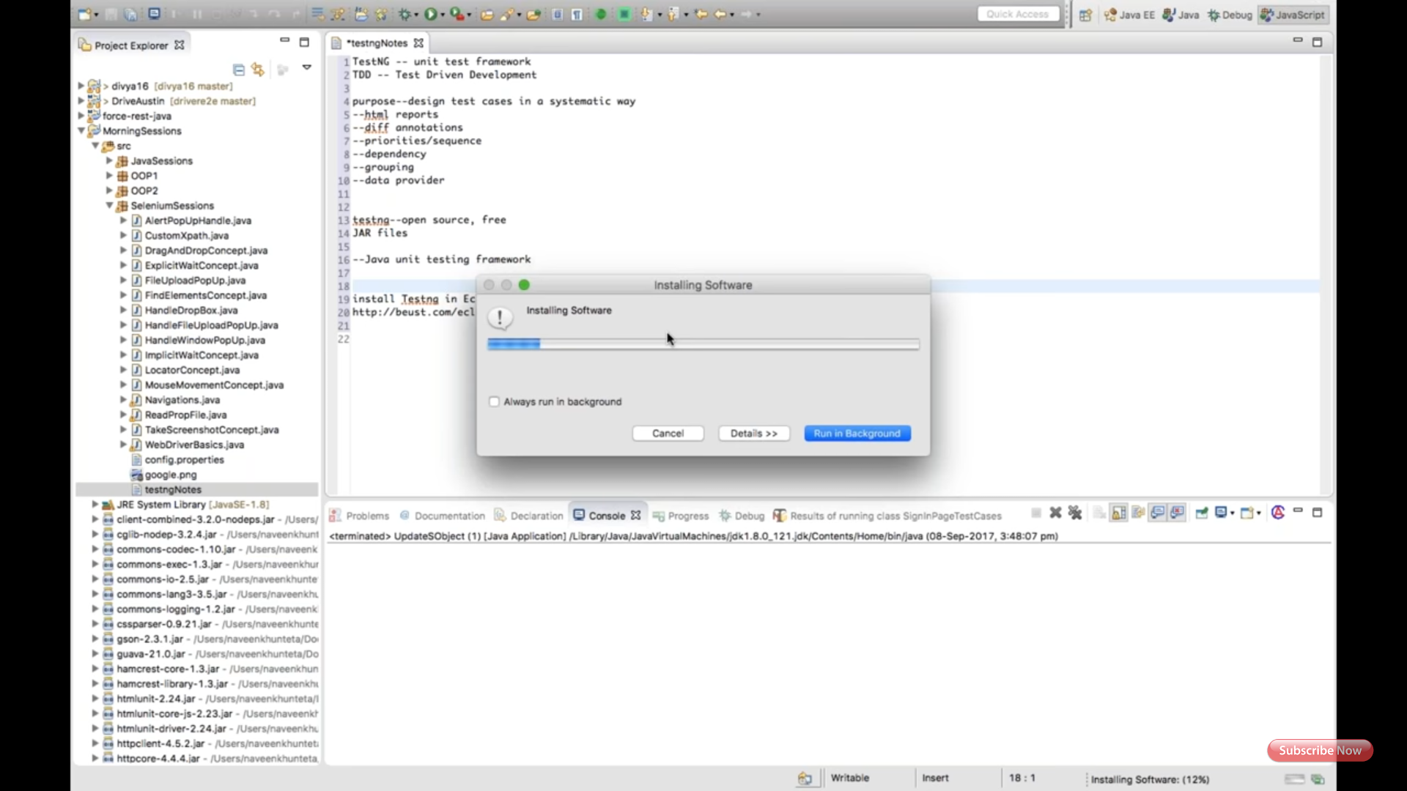

Sixth screenshot explains restart eclipse after TestNG install.

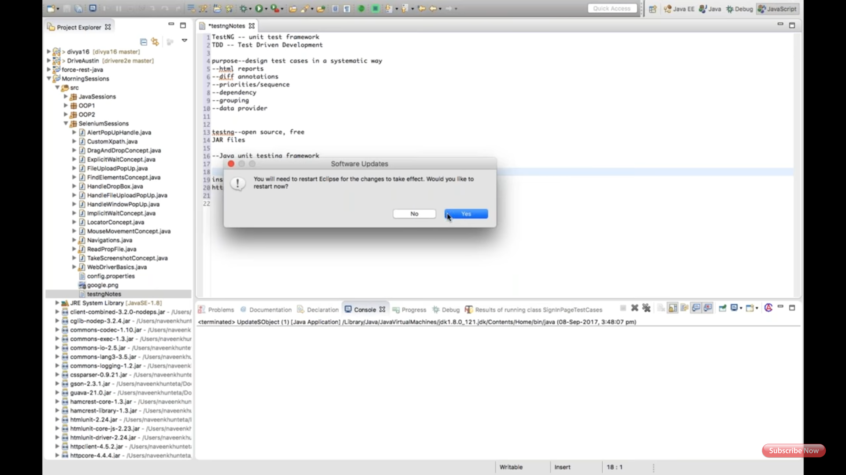

Right click on the project, select properties, select Java BuildPath, select add Library, select TestNG, select Next, select Finish.

Note: under library you can see all Selenium, Java, TestNG jar files.

Click on Apply, Click on Ok.

Seventh screenshot showing, Create package and class for TestNG, don't create main method in TestNG class, it will automatically includes.

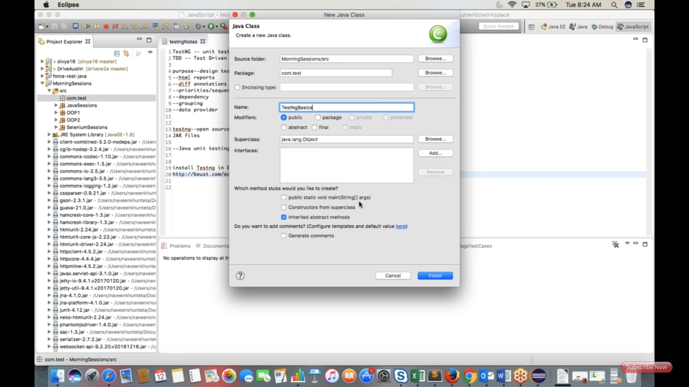

Eight screenshot explains, prerequisite annotations.

Ninth screenshot has last after suite annotation. (Ninth not available missed to attach)

Note: all @before annotations are called preconditions, @after annotations are post conditions. (For test cases, annotations starting with @test.)

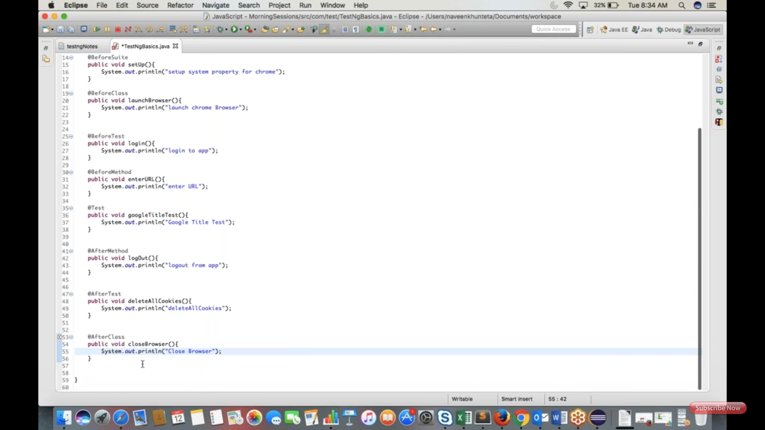

Tenth screenshot, To run the class, right click and run as TestNG.

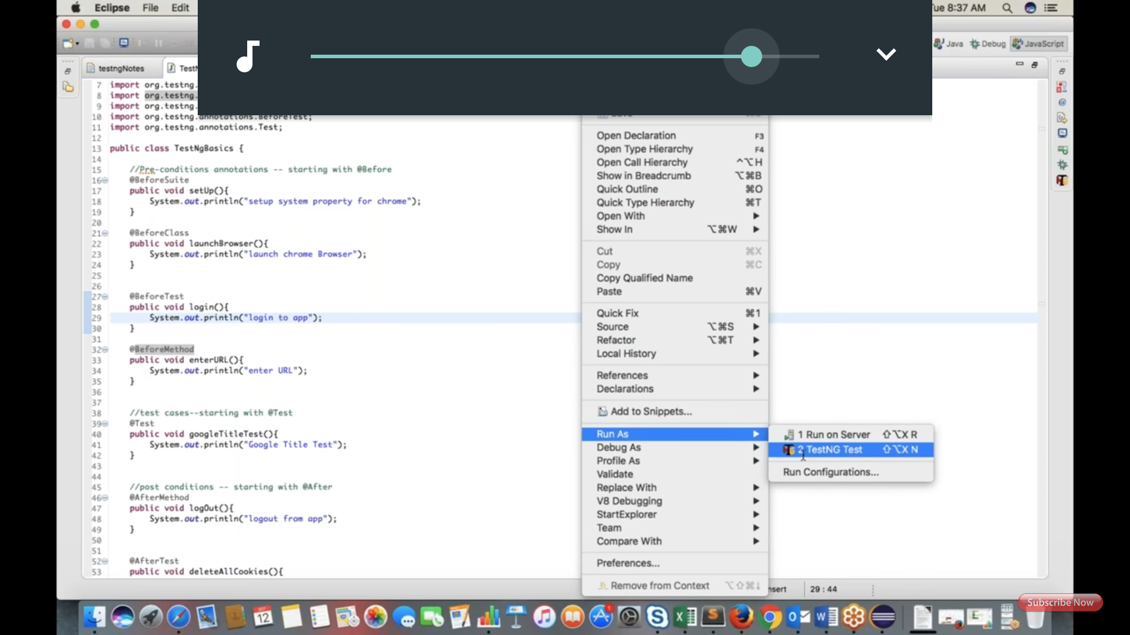

Eleventh screenshot, To run in proper sequence, set annotations as shown in comments.

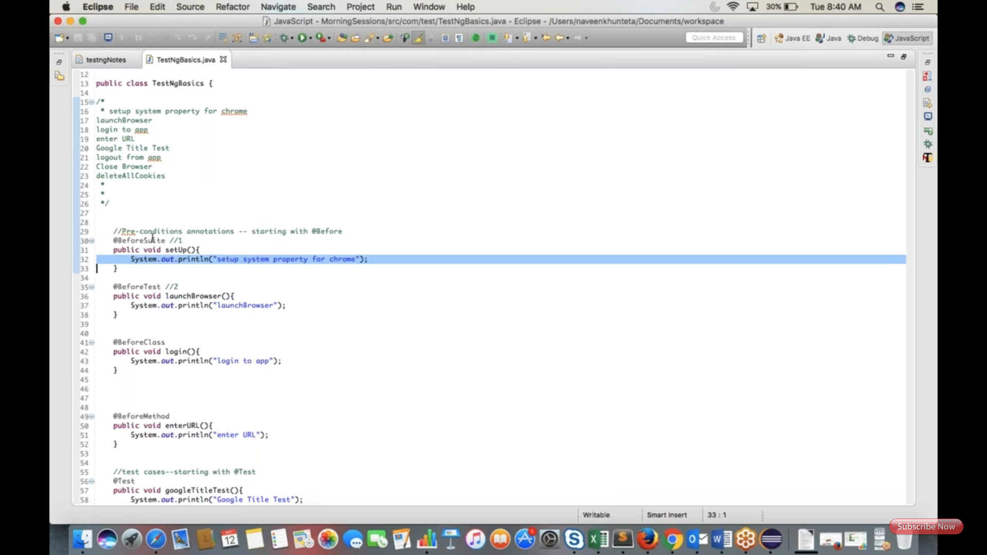

Twelfth screenshot showing how two test cases having before and after annotations for every single test case.

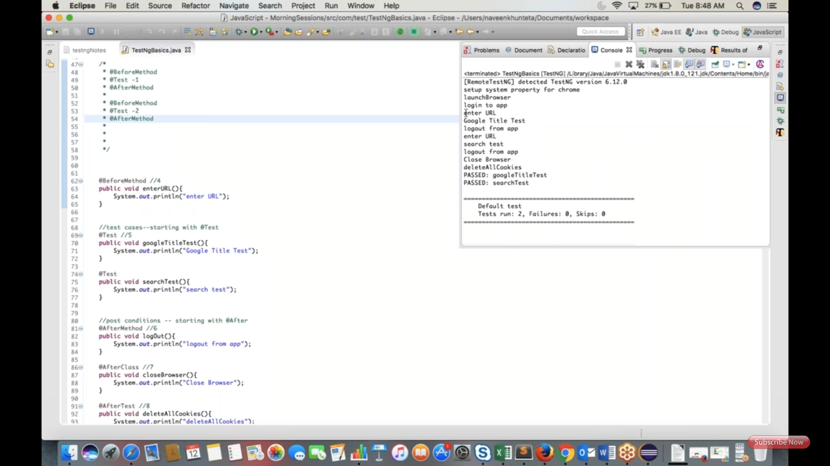

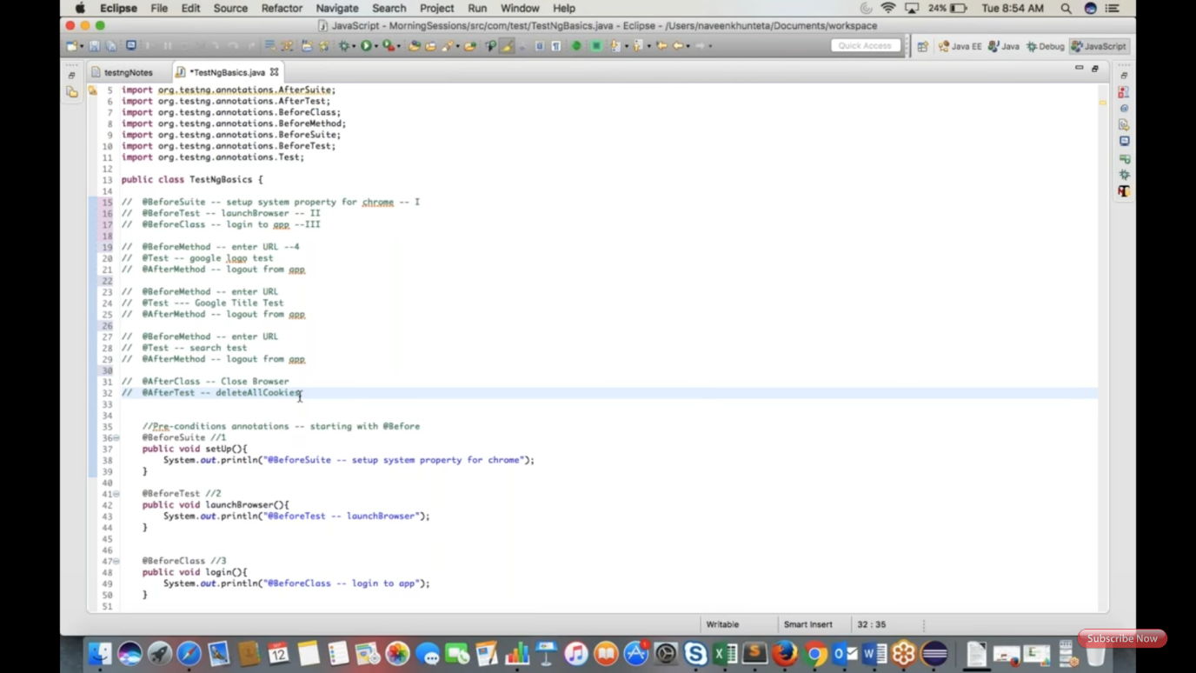

Thrteenth screenshot explains sequence of annotations for interview purpose. (Real time use only before class, before test, before method and after of these three)

Fourteenth screenshot showing TestNG test with before and after method and three test cases.

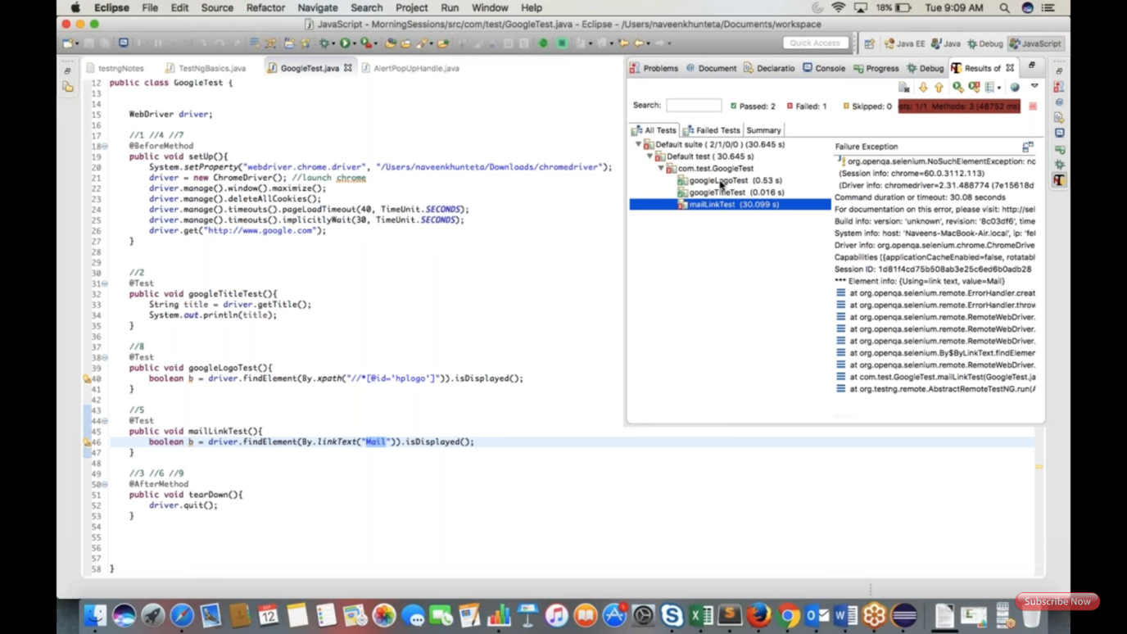

Fifteen screenshot showing TestNG prioritizing test cases execution.

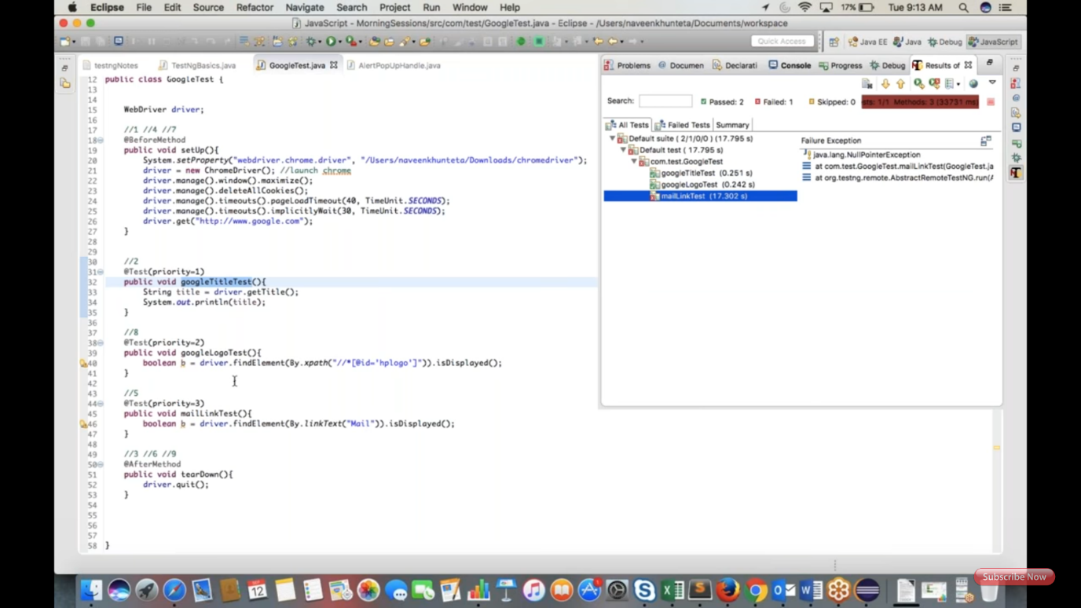

**Session2:**

First screenshot shows grouping test cases.

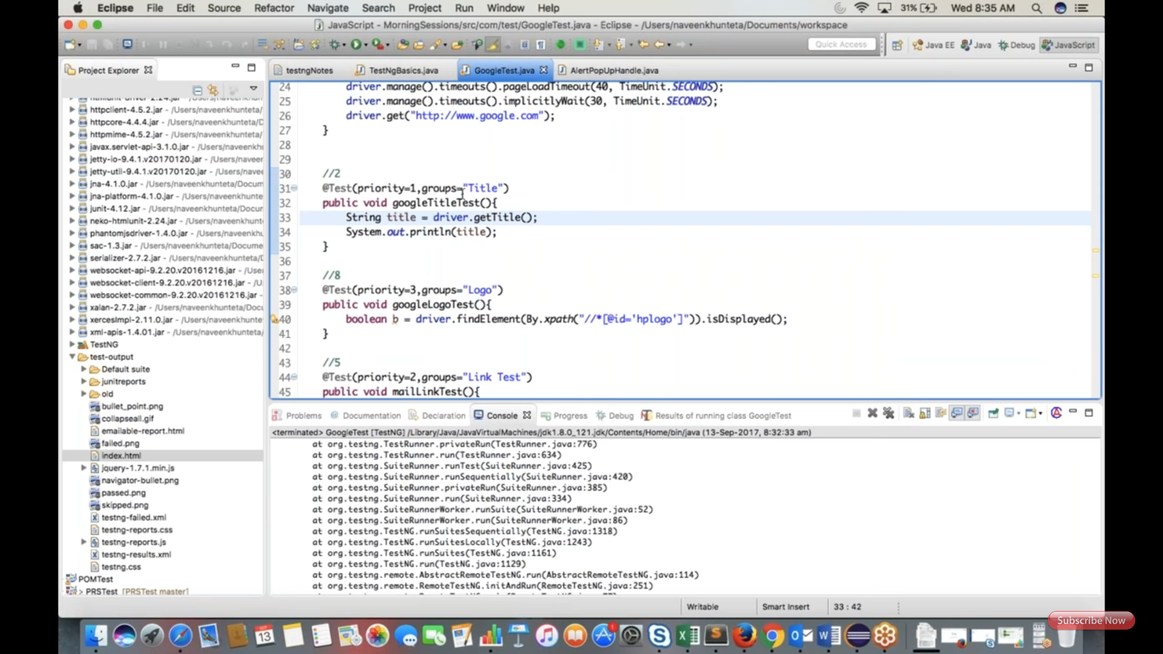

Second screenshot explains html report of TestNG with groping.

Note: to see results, right click on the project and refresh. You will see "test output" folder in that open index.html page for report.



Third screenshot explains, how depends on method used to control the execution.

Uncomment int/0 to see @Test(dependsOnMethod=loginPage)

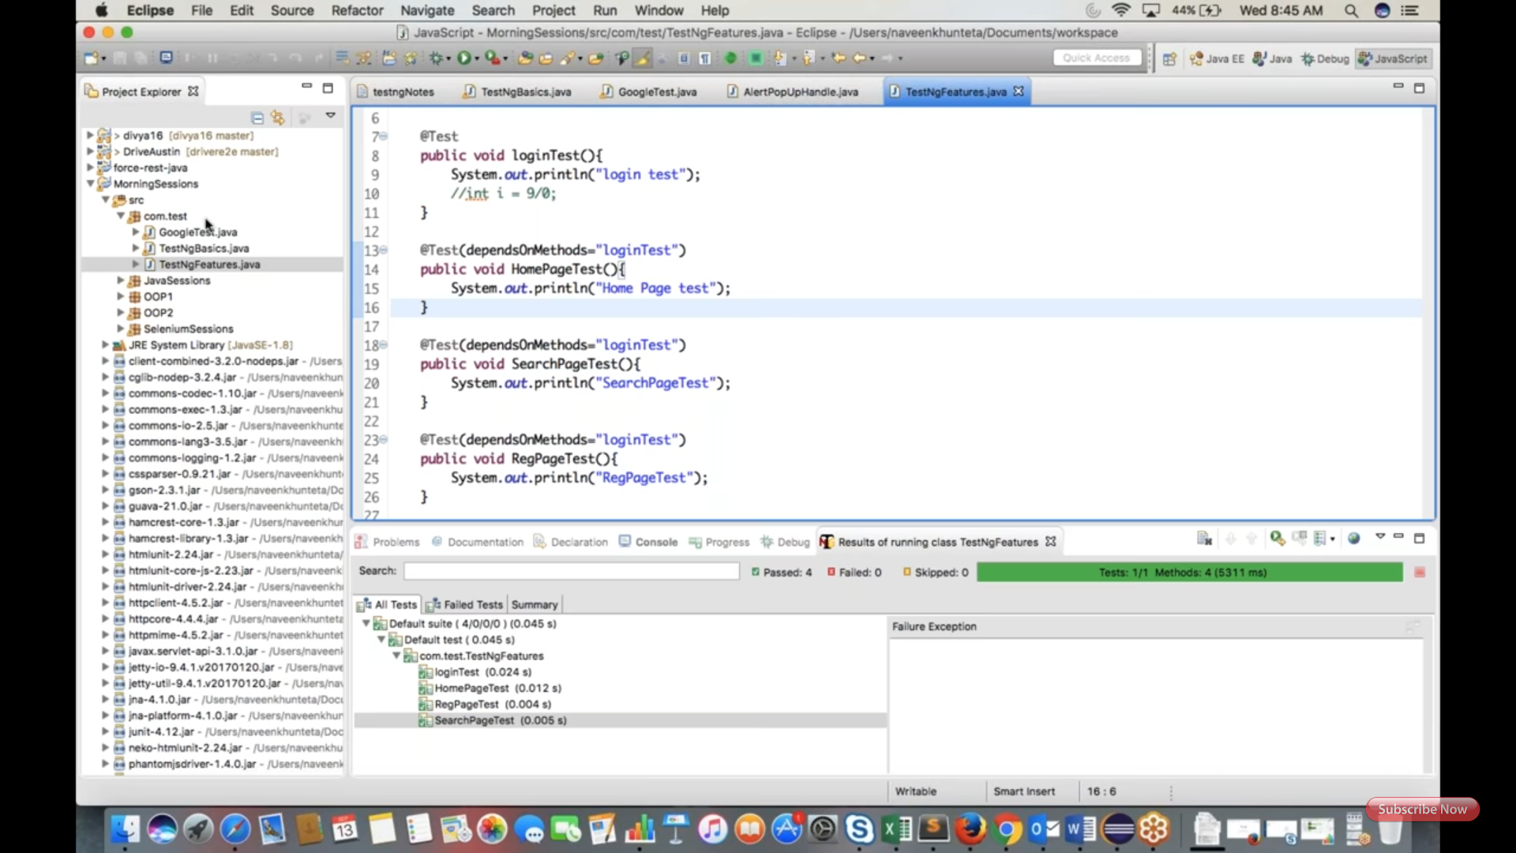

Forth screenshot explains invocation count to execute same test case more number of times.

Note: generally we don't use this.

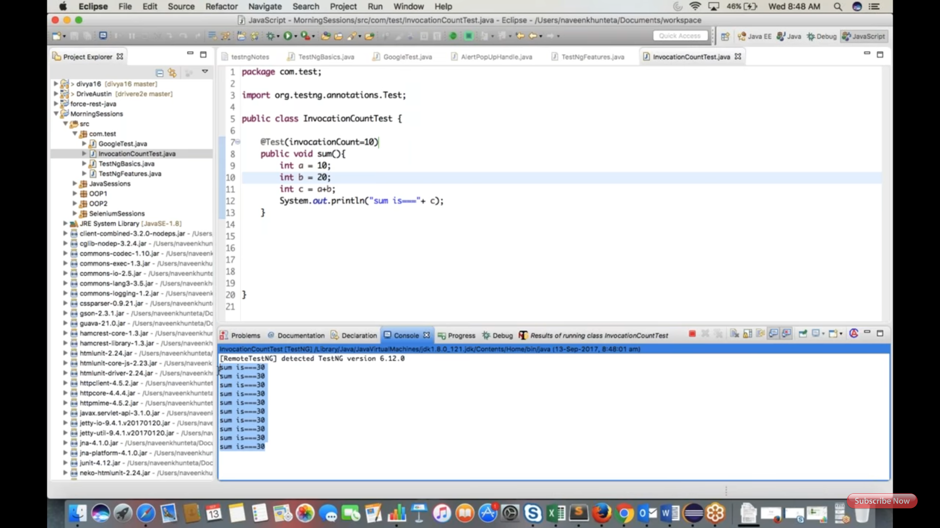

Fifth screenshot explains, invocation time out, this may be used to handle infinite looping. Note: it's not working in eclipse.

Explained another feature also, that is expected exception.

Note: generally we don't use above two.

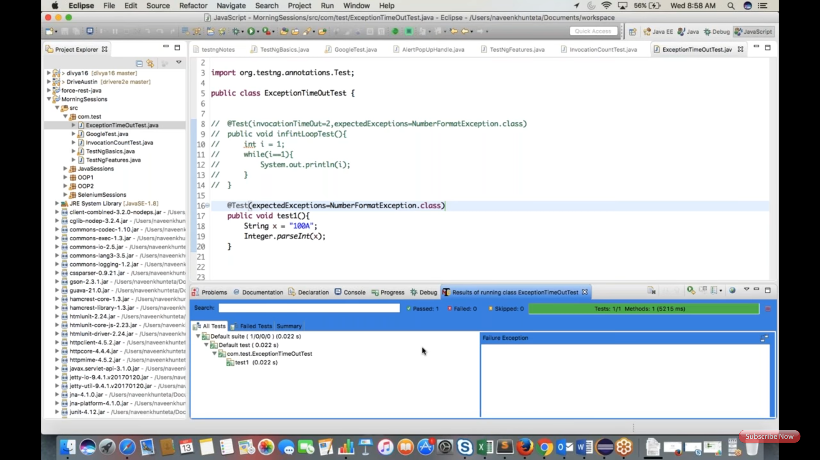

Sixth screenshot explains assertEquals and assertTrue to validate test case.

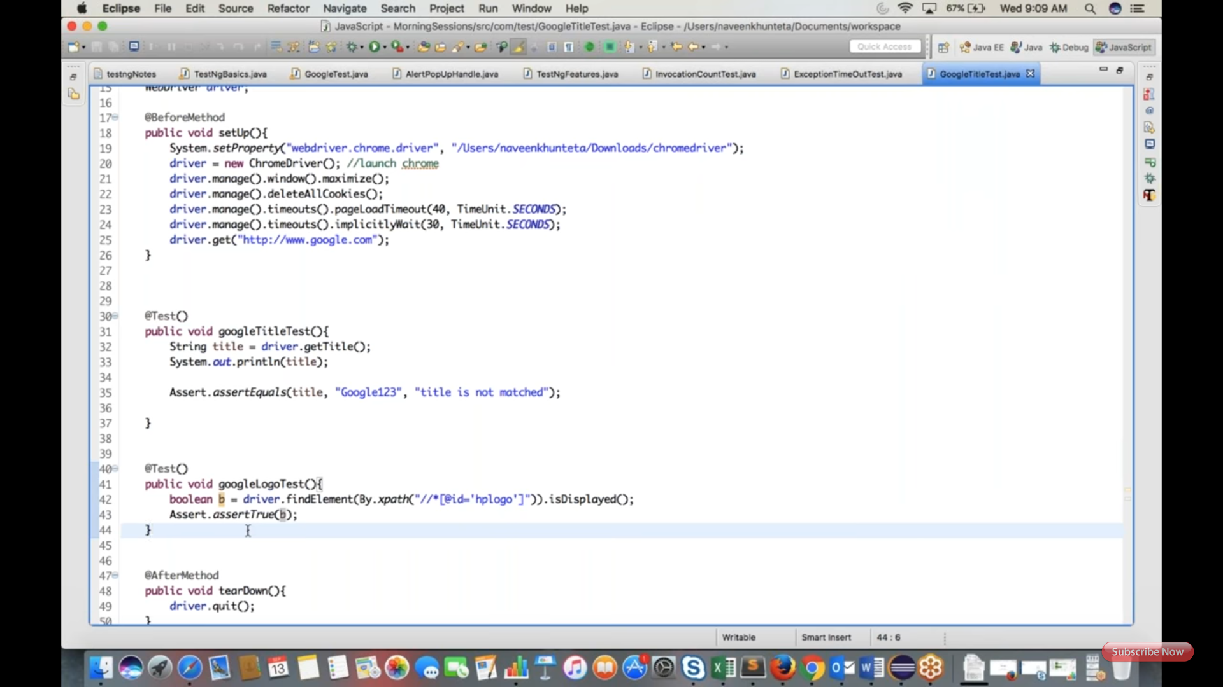

To run multiple tests at a time, we need to create XML file.

Go to src, right click, select New, select others, click on file, click on next, give file name as: testng.xml and copy paste Seventh screenshot code.

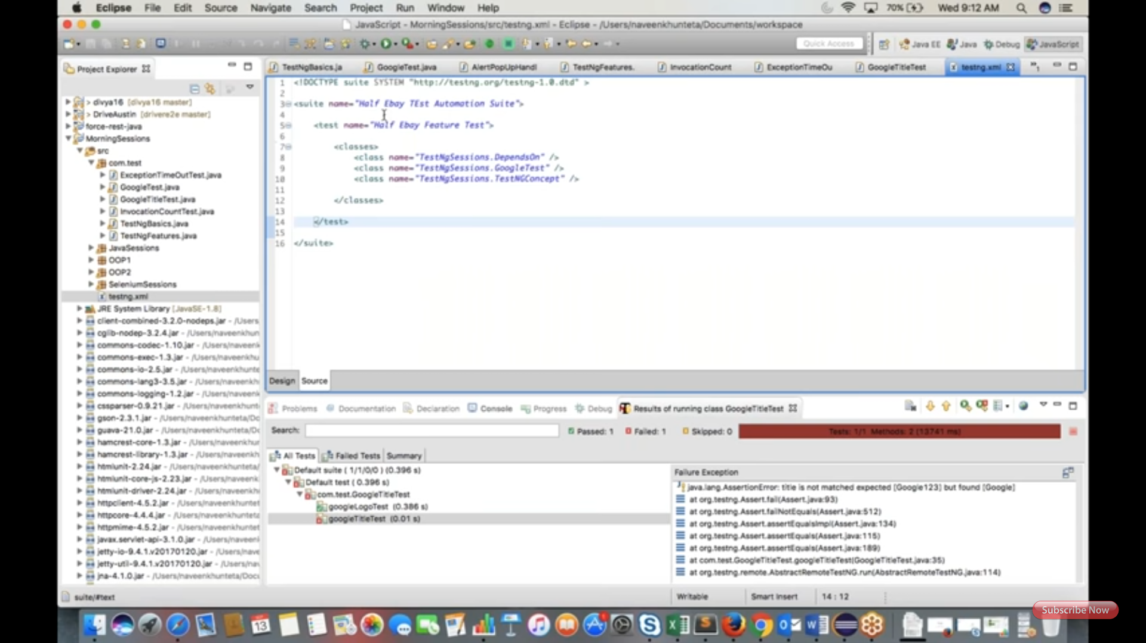

Eight screenshot explains how to modify testng.xml as per your package and test class names.

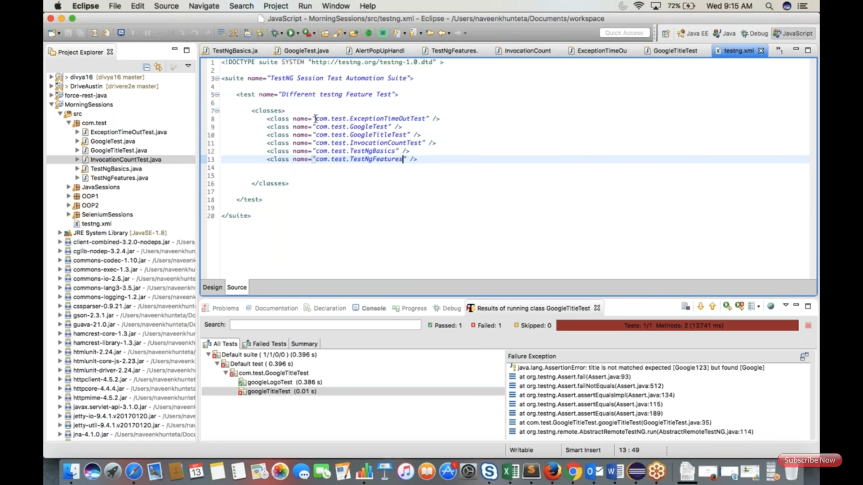

Ninth screenshot explains, right click on the the testng.xml and run to run all the tests.

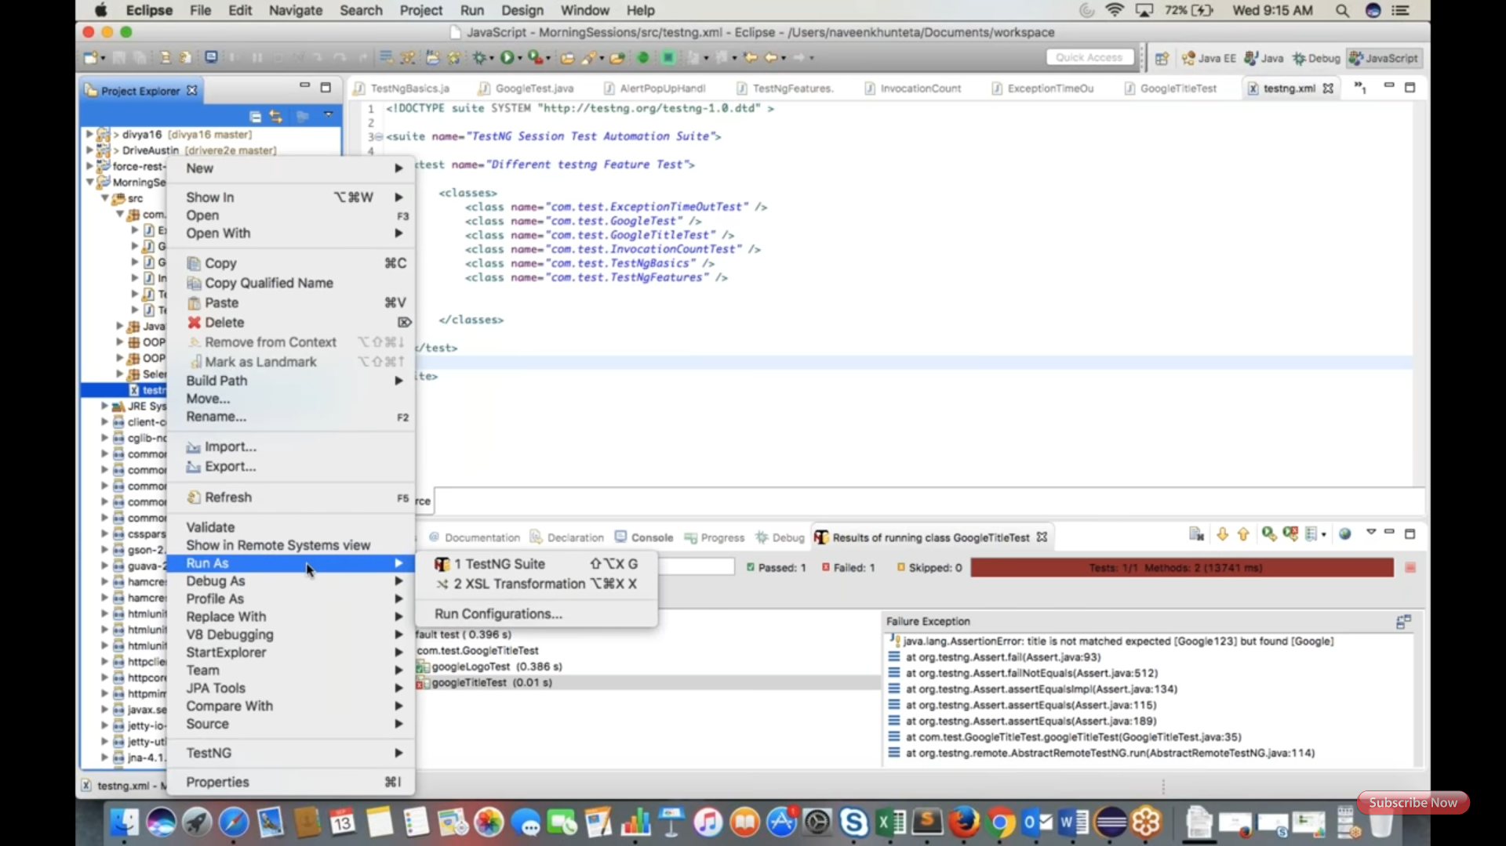

To Run Failed test case again used: testng-failed.xml (under test-output folder)

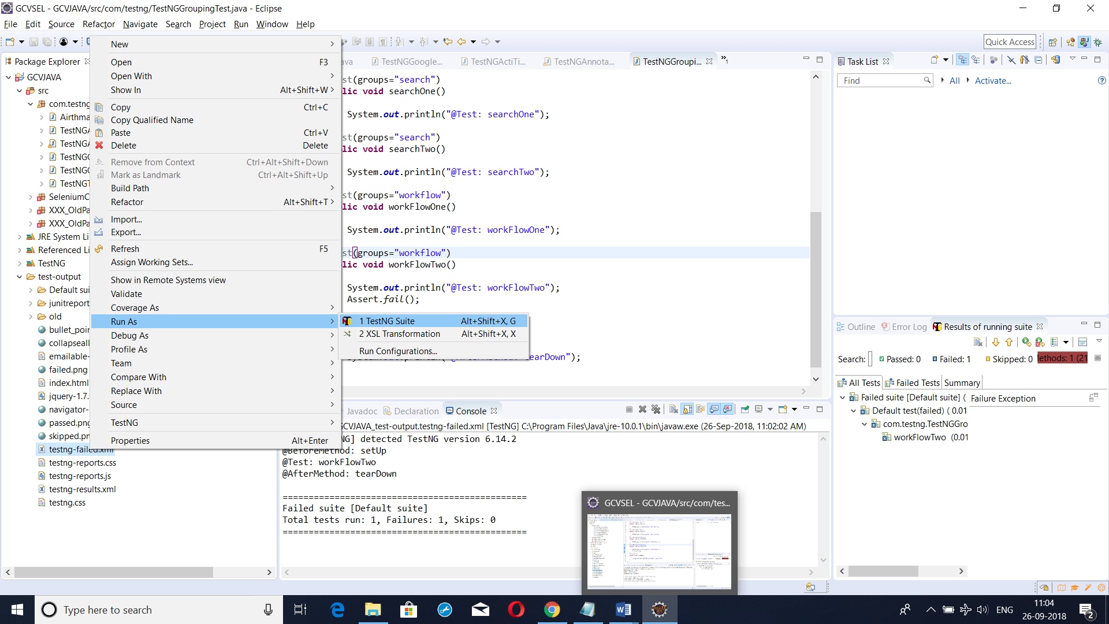

Tool Tips and TestNG Assert:

